4 Working with all browsers

Flexbox for the most part works pretty well, but it doesn’t always play nice with others. This is where vendor prefixing will come in handy.

There is something called the autoprefixer, which will help you with this, but you will need to install it in Visual Studio Code.

# Open Visual Studio

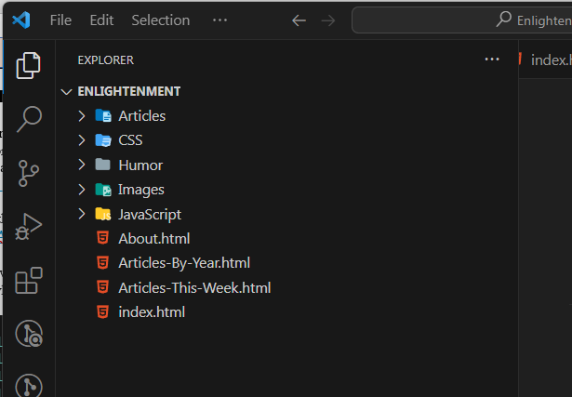

Go to the left side and click on this icon that looks like 4 boxes with the top right one shooting out to the right.



Add to the search bar the text “autoprefixer” to find the extension that you will need.

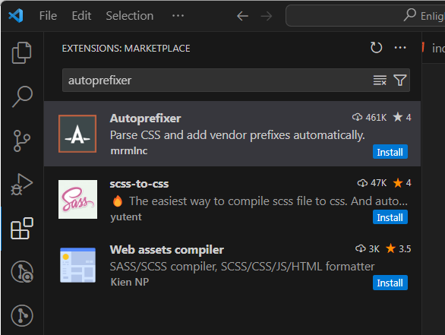

Click on the blue button for it that says “Install”

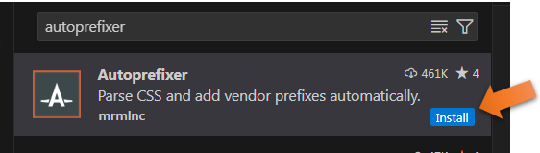

You will see the information for the Autoprefixer on the right-hand side

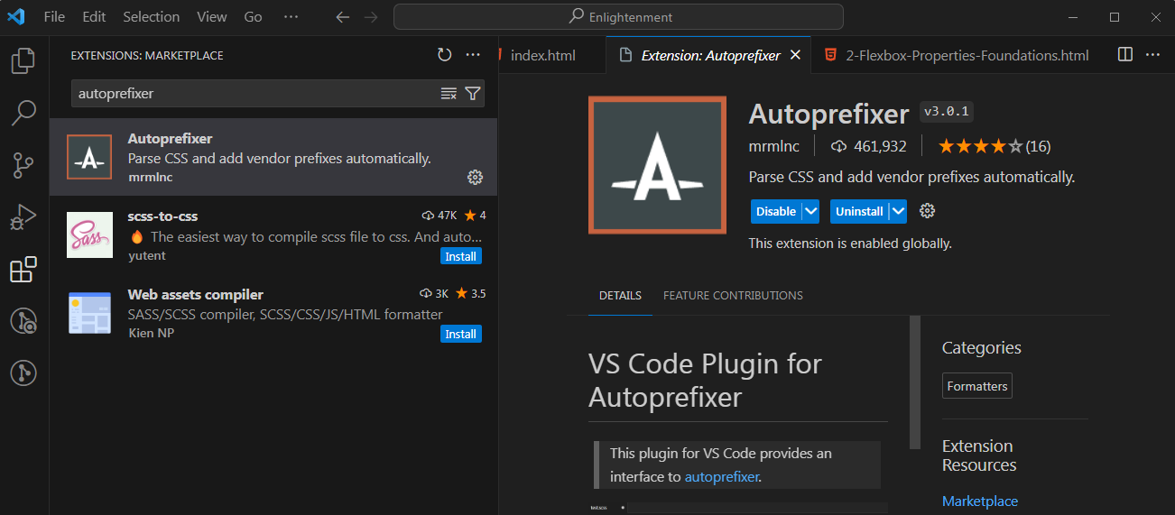

# Open Settings in Visual Studio

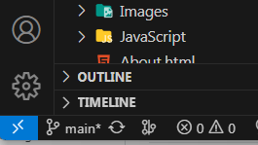

You are looking for the workspace settings for JSON, or you will not be able to edit it.

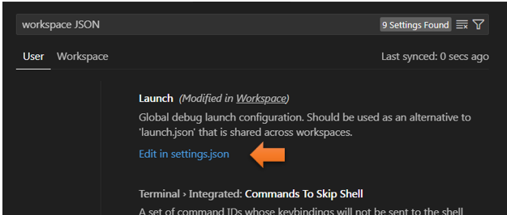

# You want to add this code to the JSON File

You will need to start by adding 2 commas to make this work. One comma goes after the last list item in the list, and another comma will be following the last curly brace. In order to add another item, the previous item must be closed out like this. Commas tell JSON that there is another item to look at.

Add a comma here, and here.

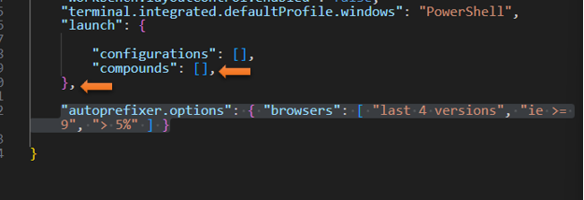

"autoprefixer.options": { "browsers": [ "last 4 versions", "ie >= 9", "> 5%" ] }

Make sure that yellow curly brace closes out the entire code for the JSON file. You can see that the code is correct if you color coding is not showing red.

# Restart Visual Studio

Now you will want to shut down and restart Visual Studio

Select text you want prefixed

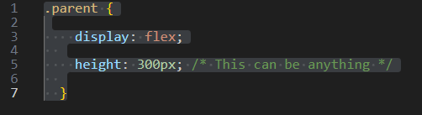

Select the text that you want to prefix and then hit F1, from the drop down at the top of the app choose

Autoprefixer:Run

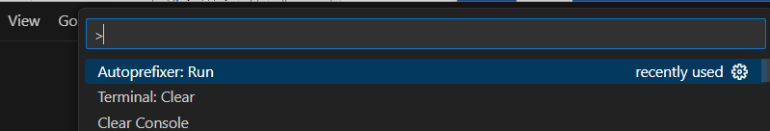

Now look at our code. IT WORKS!

